Q4) We run an identical simulation as question 3. We obtain the values of the new transfer function P, which is a feedback of the other transfer functions of the DC motor.

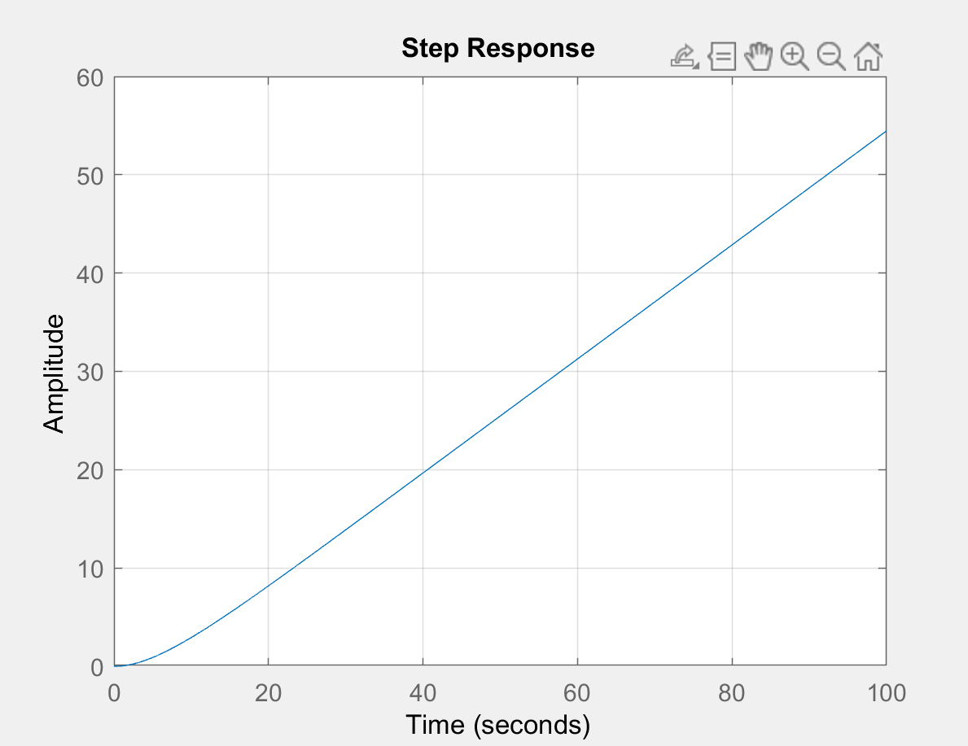 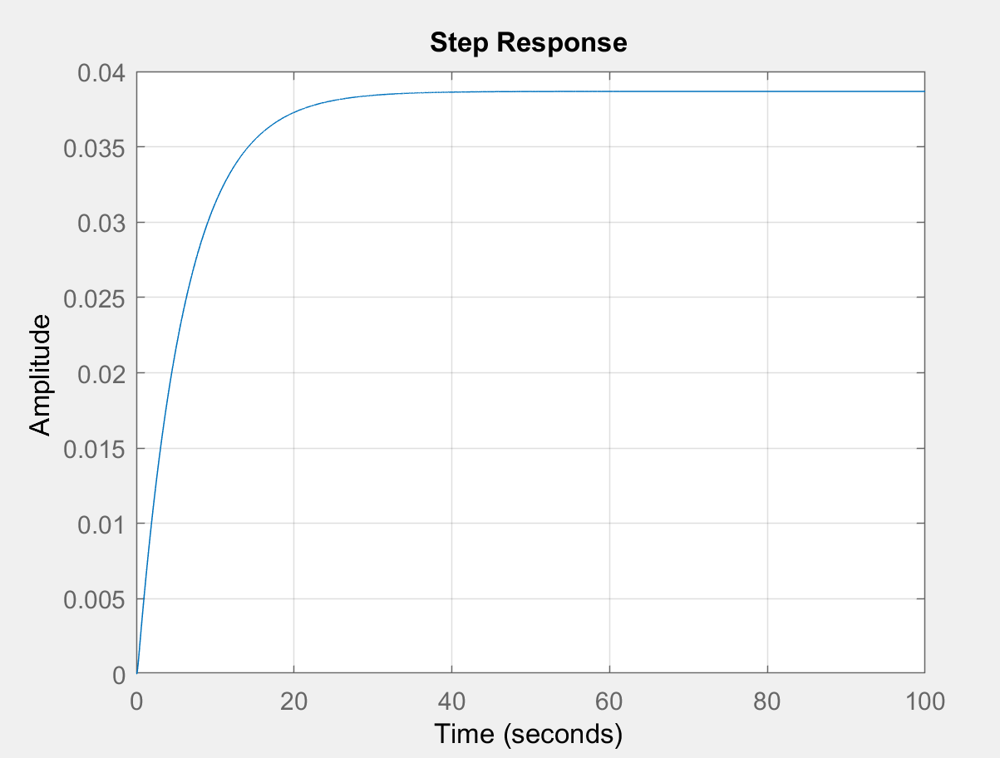

P\*G1 P\*G2

As we can see we obtain similar results as we did for the previous part on Simulink.

Q5) In this question we add the gear ratio to the transfer function. After adding the gear ratio the transfer function changes to

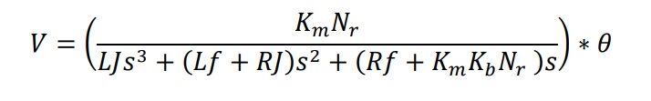

And when we neglect the inductor L=0

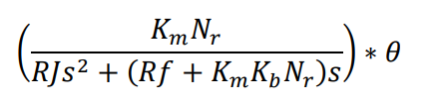

The consideration of the gear ratio does not affect the system as P=0, will make the system unstable

Q6) We have been given $\left|\tilde{θ}\right|=θ$ which has directions clockwise and counter clockwise respectively. From this we can say that the block diagram $K_{i}$ need to equal -1 to satisfy the equality condition. The direction of the load voltage is same as the direction of the rotation angle $\left|\tilde{V}\right|=V, K_{0}$ also needs to be equal to -1 in order to satisfy the direction equality constraints. From this we can see that $K_{i}*K_{0}=-1*-1=1$.